**Week 2**

**Jupyter Notebook and JupyterLab**

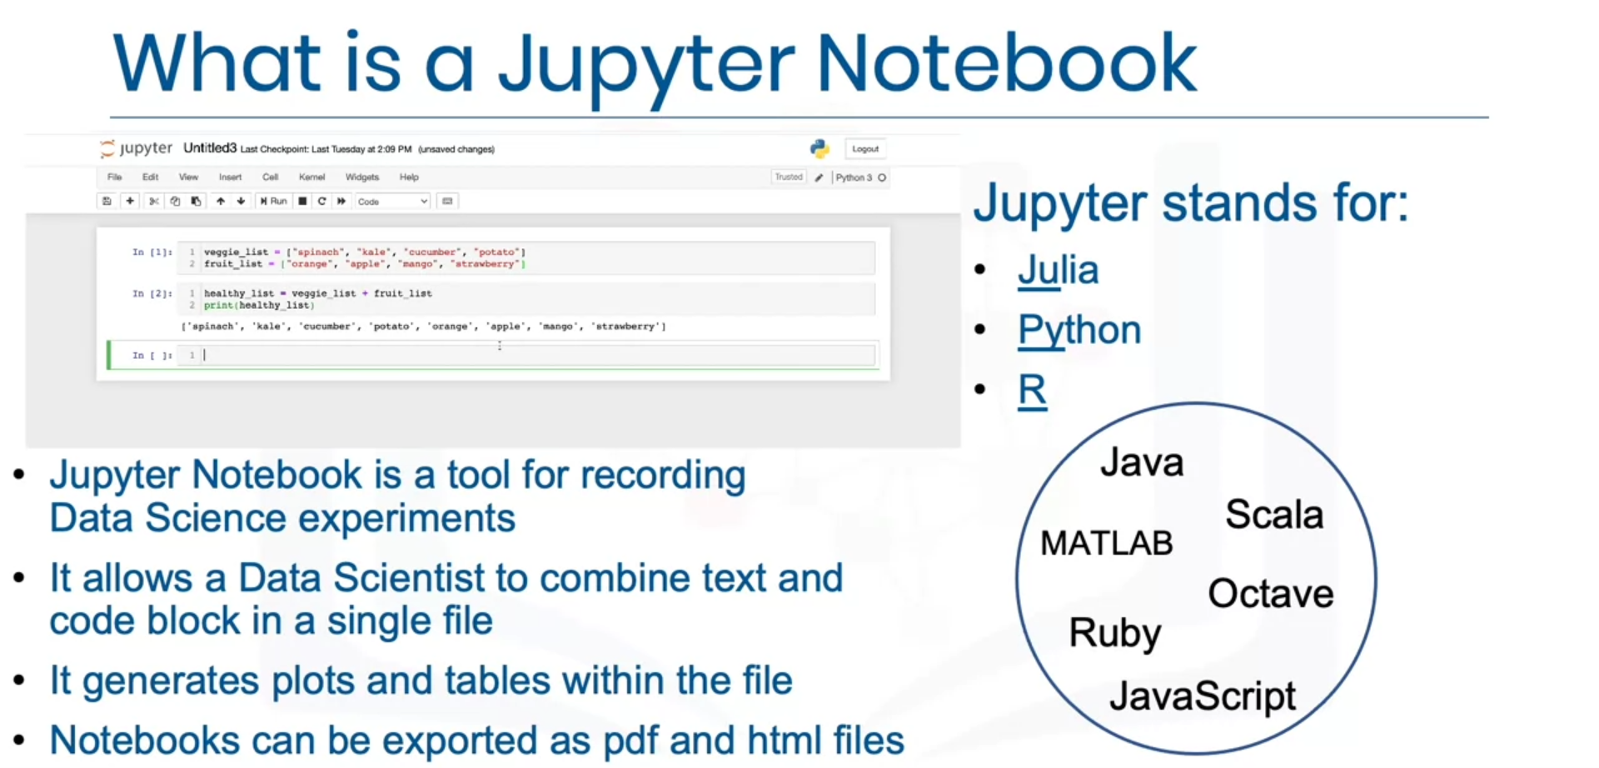

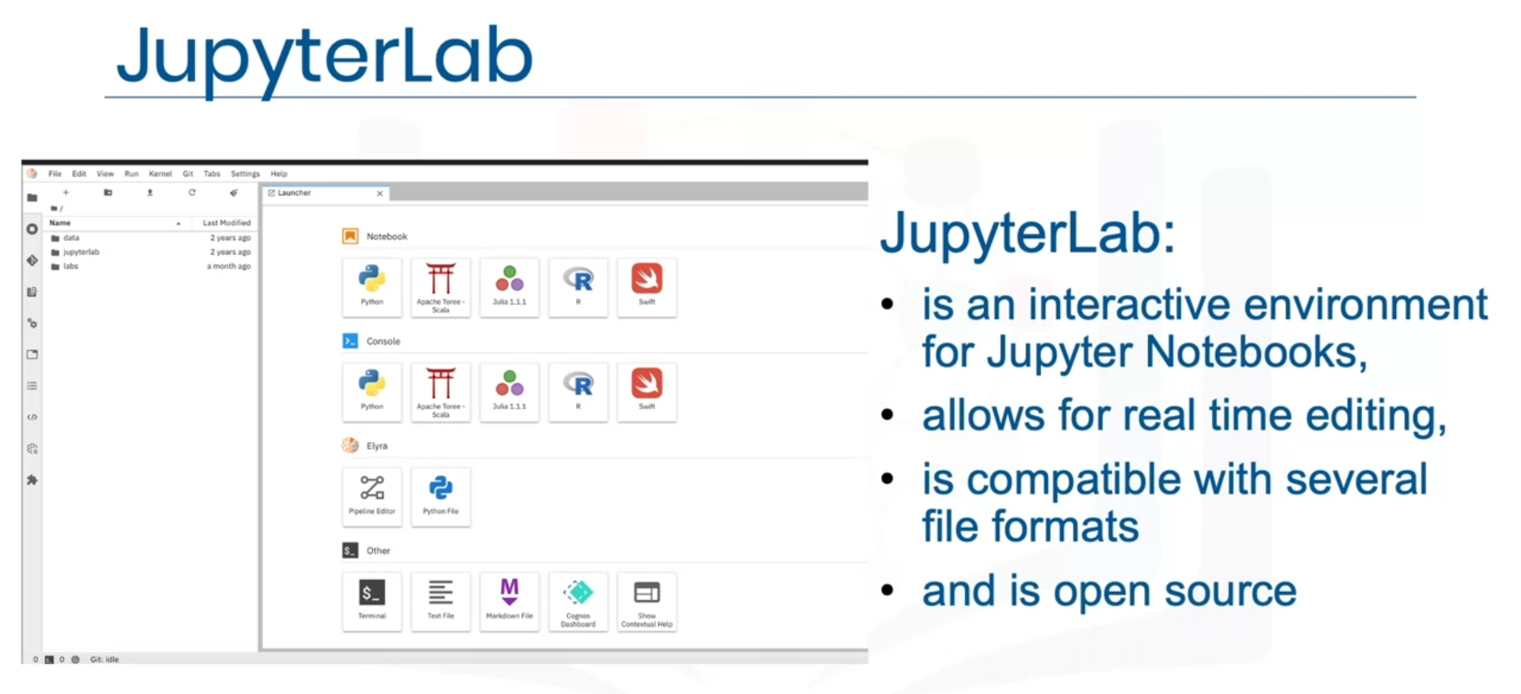

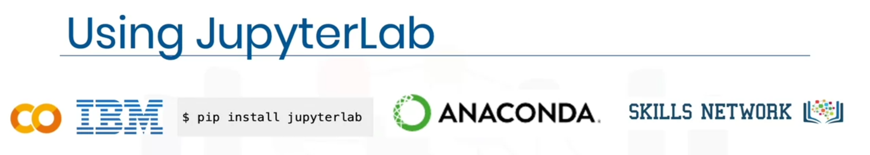

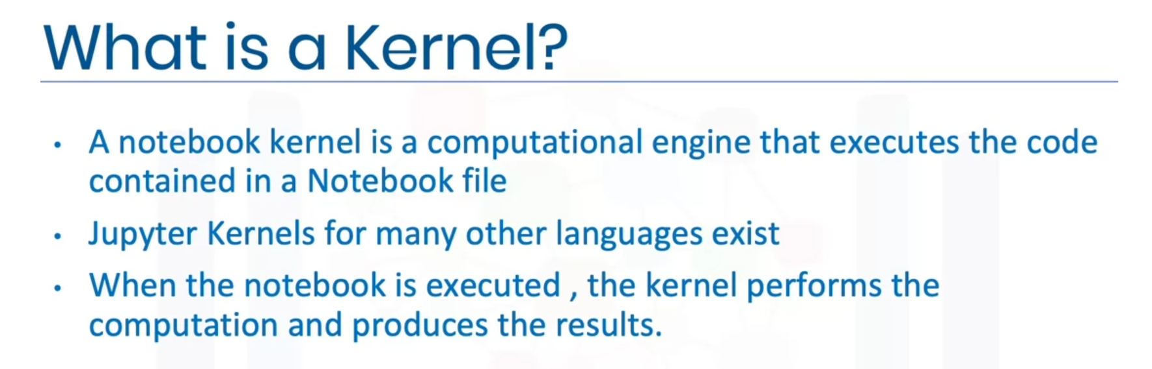

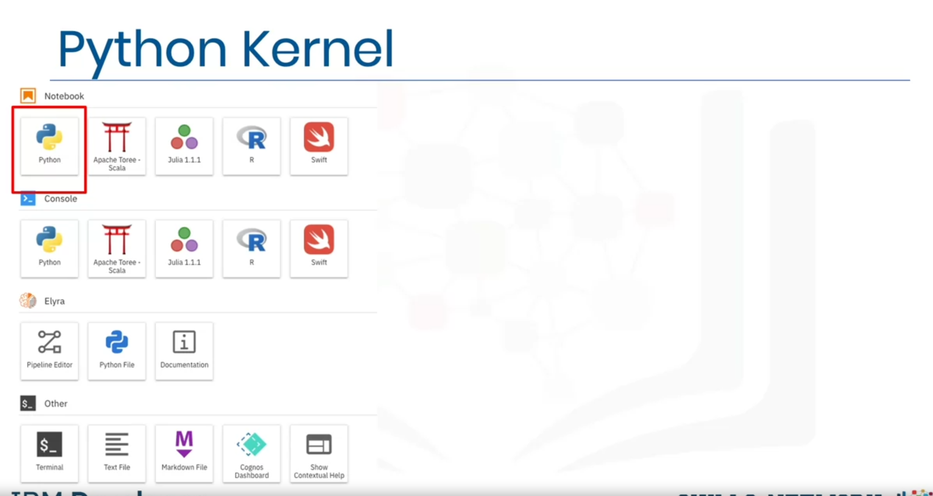

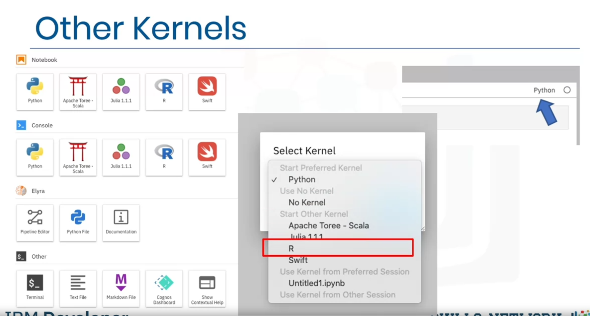

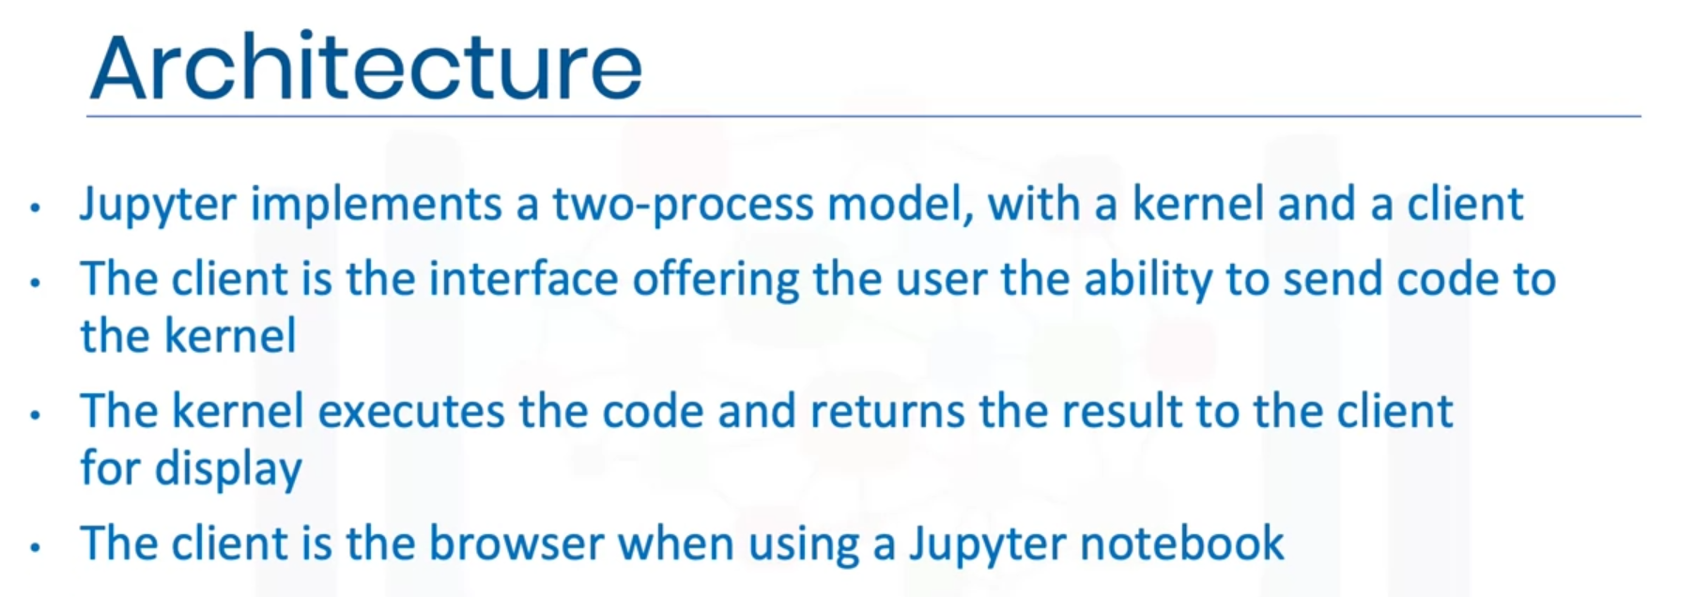

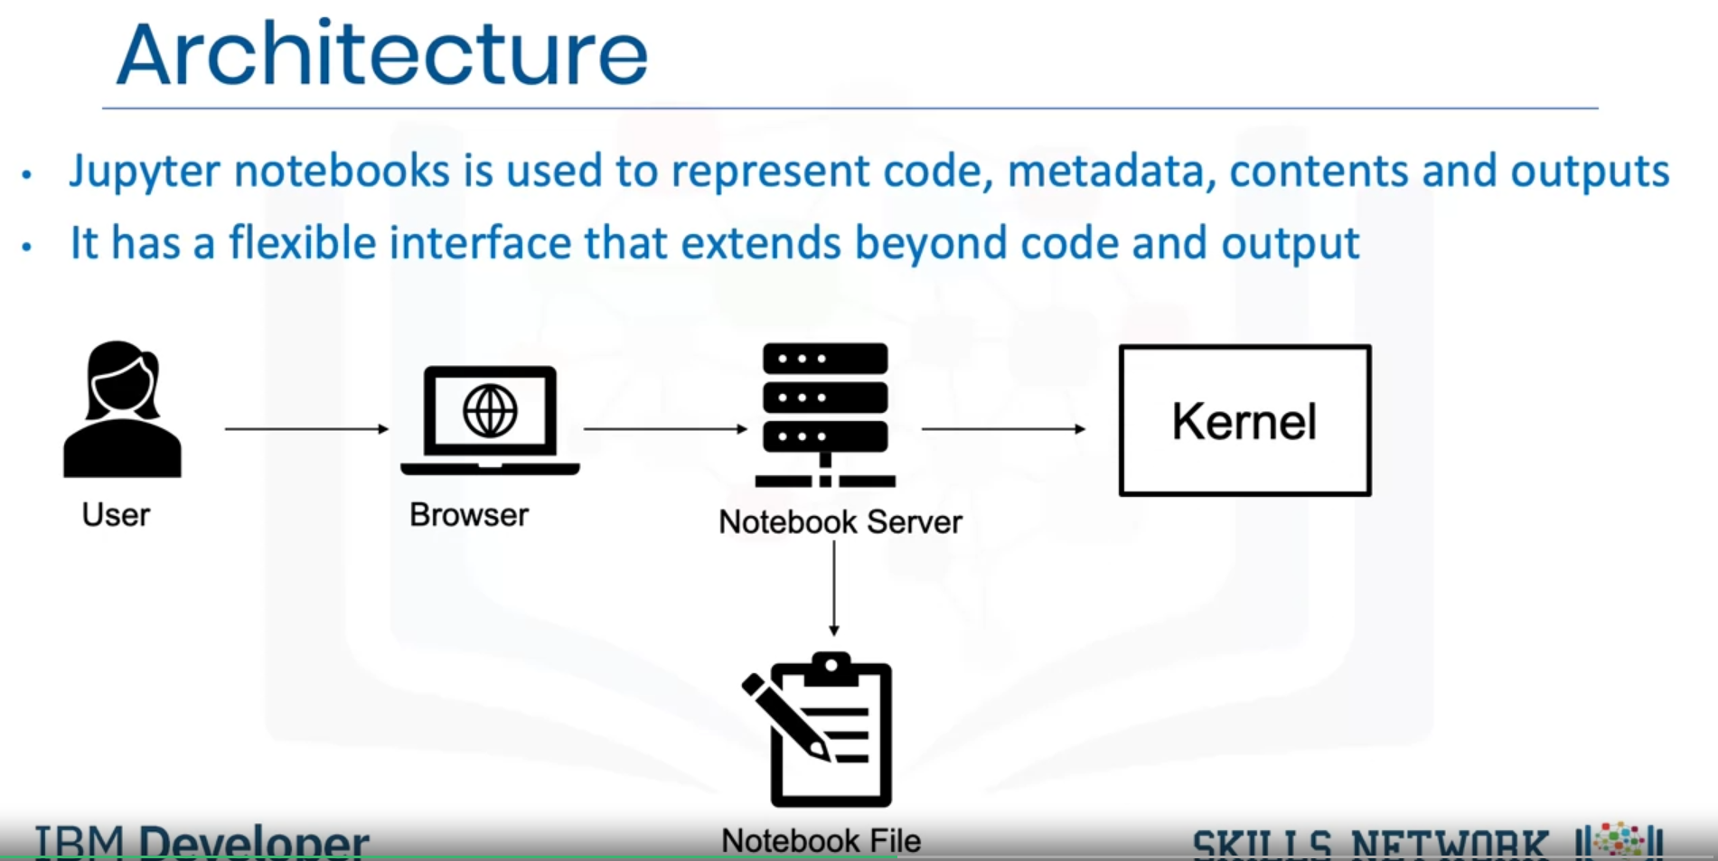

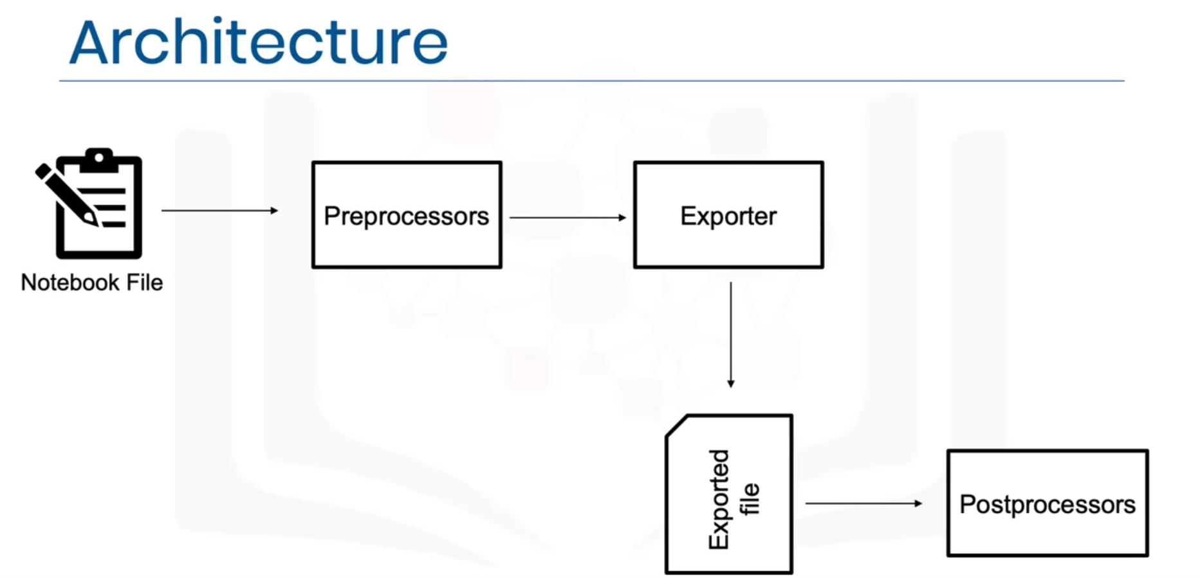

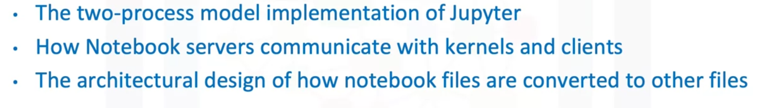

### Jupyter Notebooks on the Internet

There are thousands of interesting Jupyter Notebooks available on the internet for you to learn from. One of the best sources is: <https://github.com/jupyter/jupyter/wiki>

It is important to notice that you can download such notebooks to your local computer or import them to a cloud based notebook tool so that you can rerun, modify, and apply what's explained in the notebook.

Very often, Jupyter Notebooks are already shared in a rendered view. This means that you can look at them as if they were running locally on your machine. But sometimes, folks only share a link to the Jupyter file (which you can make out by the *.ipynb extension). In this case, you can pick the URL to that file and paste it to the NB-Viewer => <https://nbviewer.jupyter.org/>

The list of Jupyter Notebooks provides you with a huge collection of materials to explore. Therefore, it might be useful to give you some pointers to interesting notebooks. You have covered some examples with data in the labs. Let's highlight some useful data that further explores data science. In addition, as we have covered different tasks in data science, we will also provide a sample notebook for each task.

First, you start with exploratory data analysis, for which this notebook is highly recommended: <https://nbviewer.jupyter.org/github/Tanu-N-Prabhu/Python/blob/master/Exploratory_data_Analysis.ipynb>

For data integration/cleansing at a smaller scale, the python library_pandas_is often used. For this task, you can have a look at this notebook: <https://towardsdatascience.com/data-cleaning-with-python-using-pandas-library-c6f4a68ea8eb>

If you want to know more about clustering, have a look at this notebook: <https://nbviewer.jupyter.org/github/temporaer/tutorial_ml_gkbionics/blob/master/2%20-%20KMeans.ipynb>

And finally, if you want an in-depth notebook on the_iris_dataset, have a look at this: <https://www.kaggle.com/lalitharajesh/iris-dataset-exploratory-data-analysis>

**RStudio IDE**

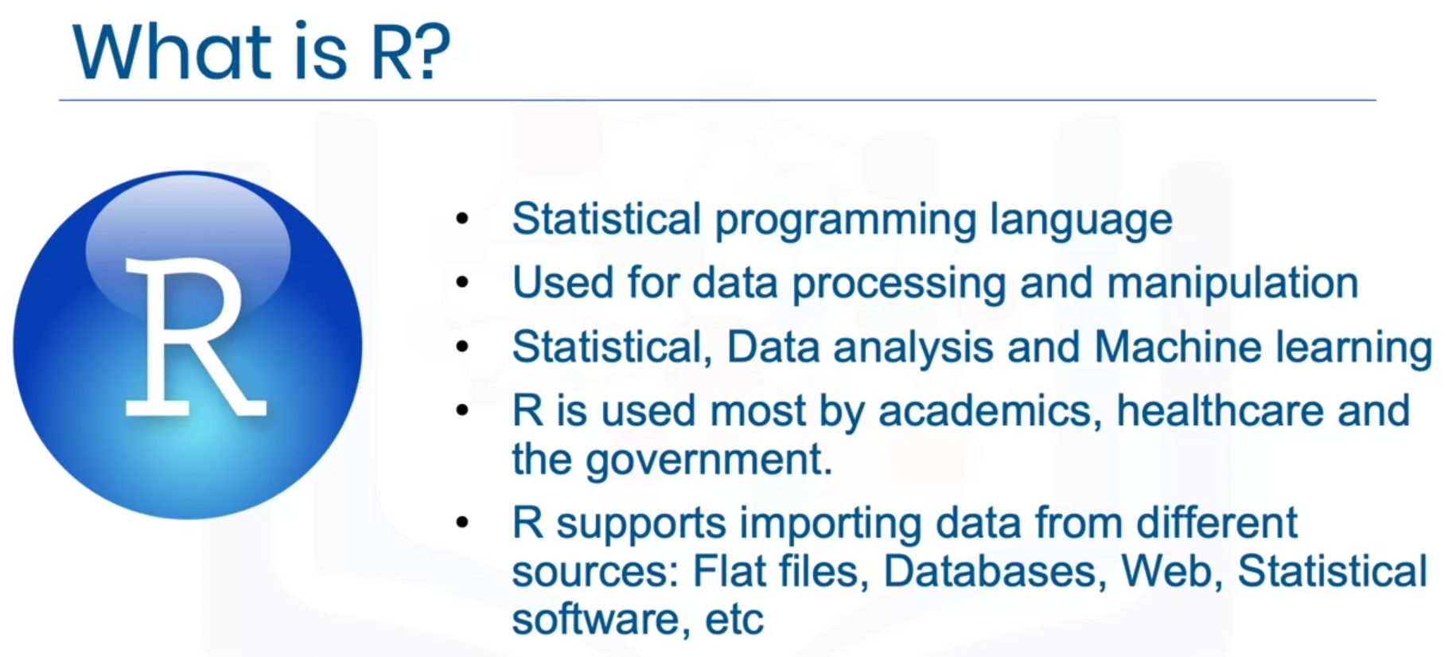

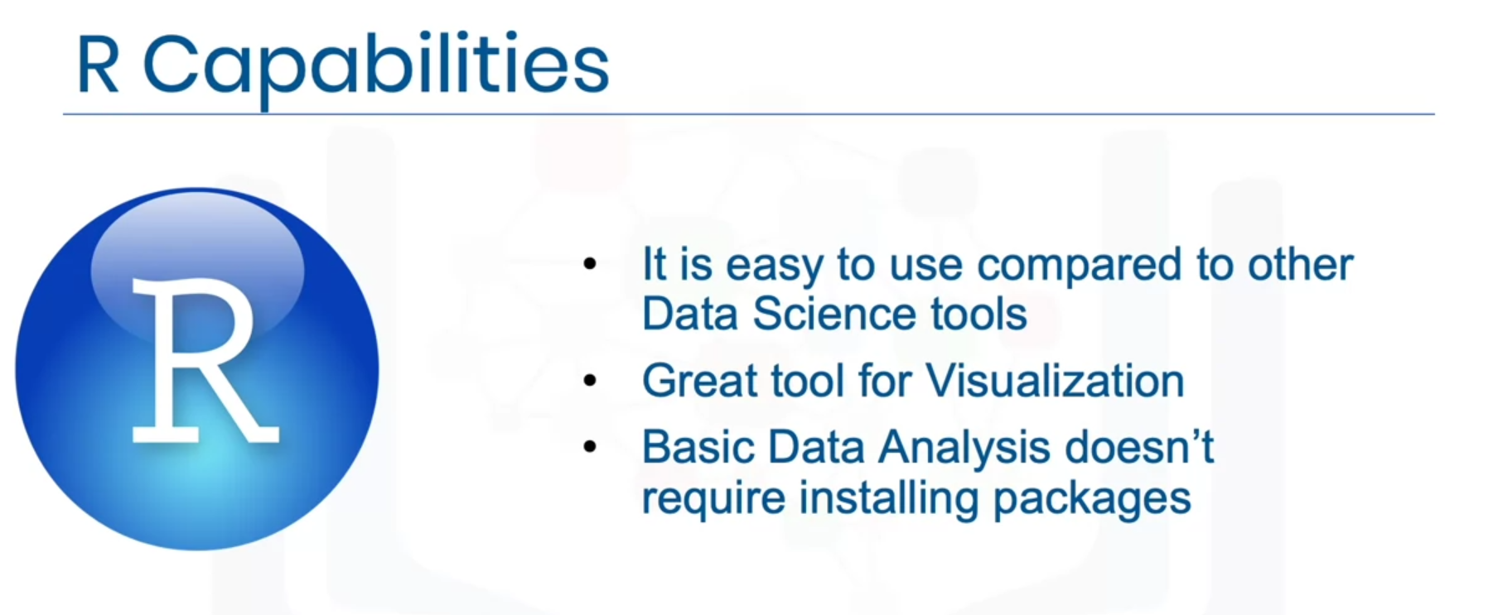

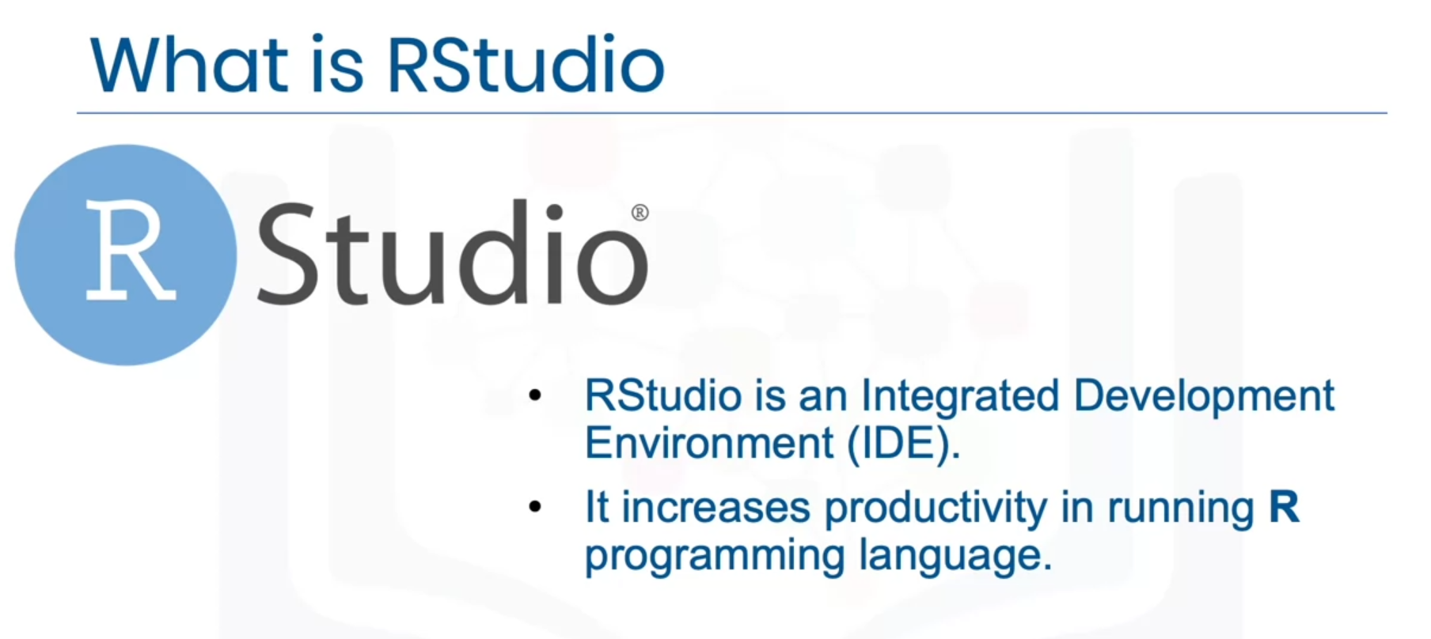

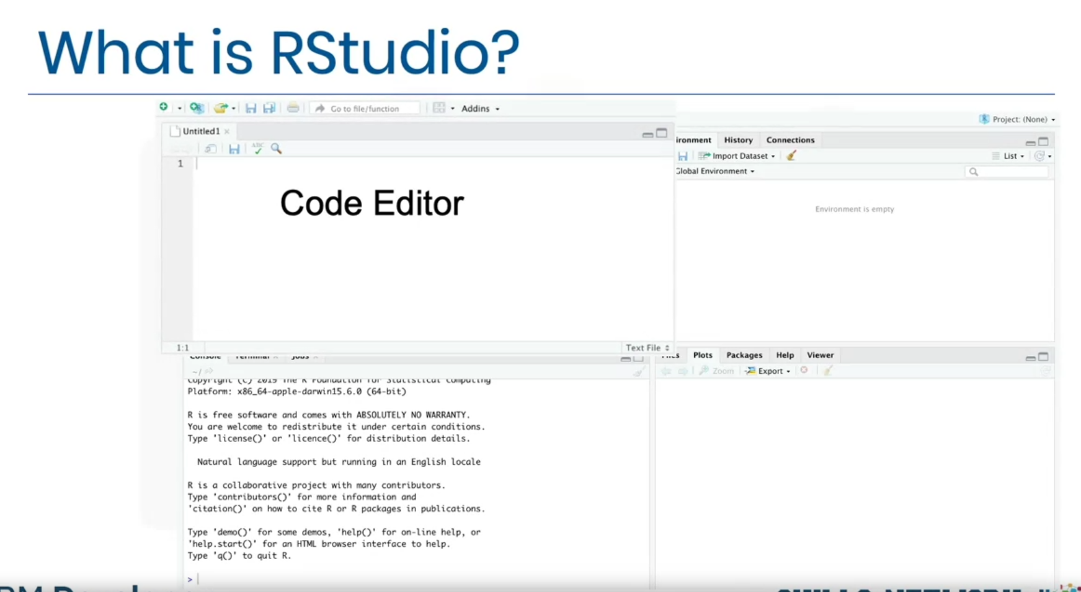

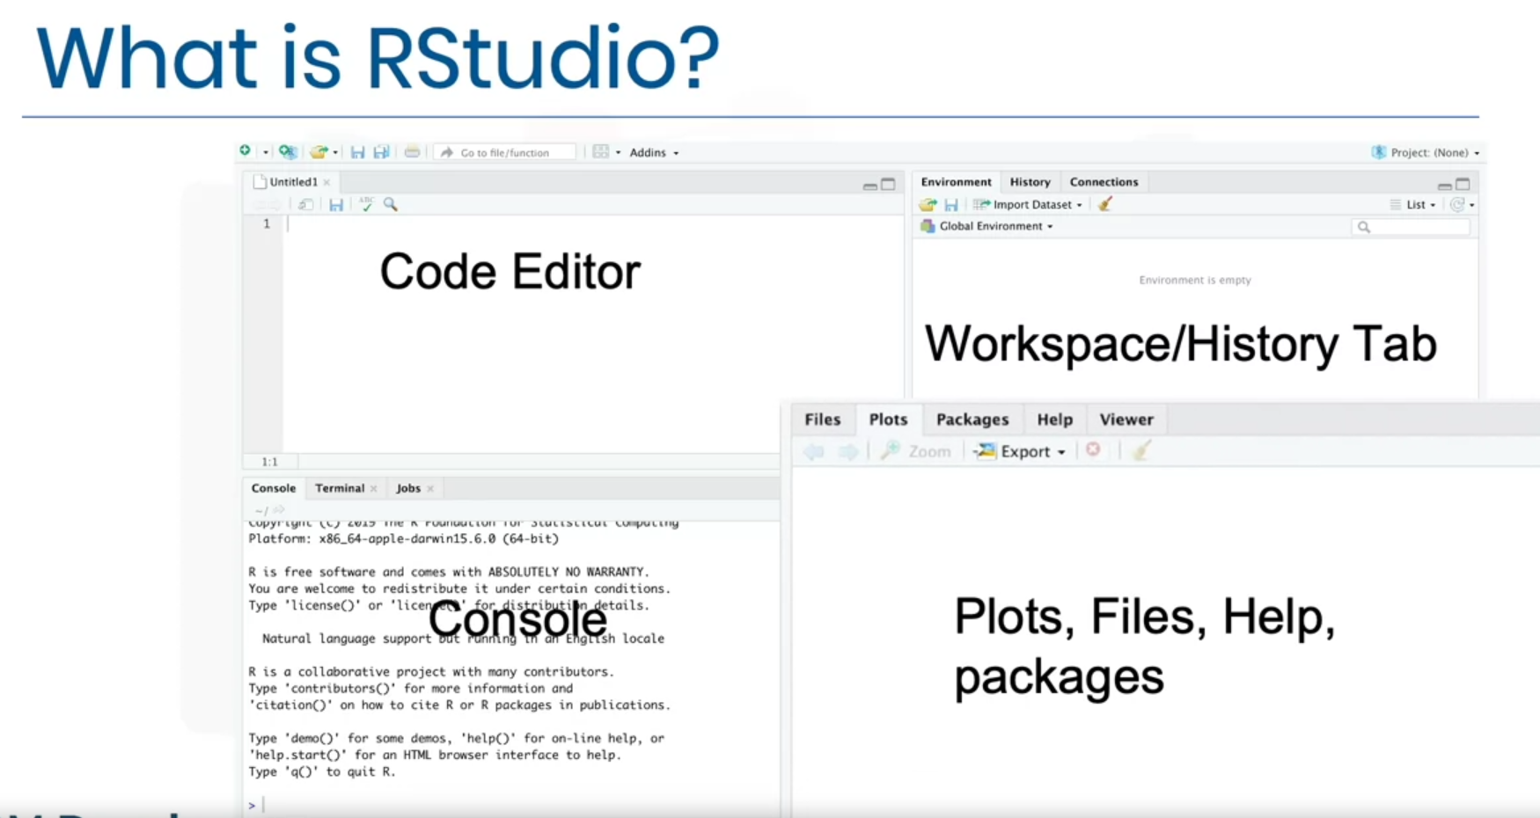

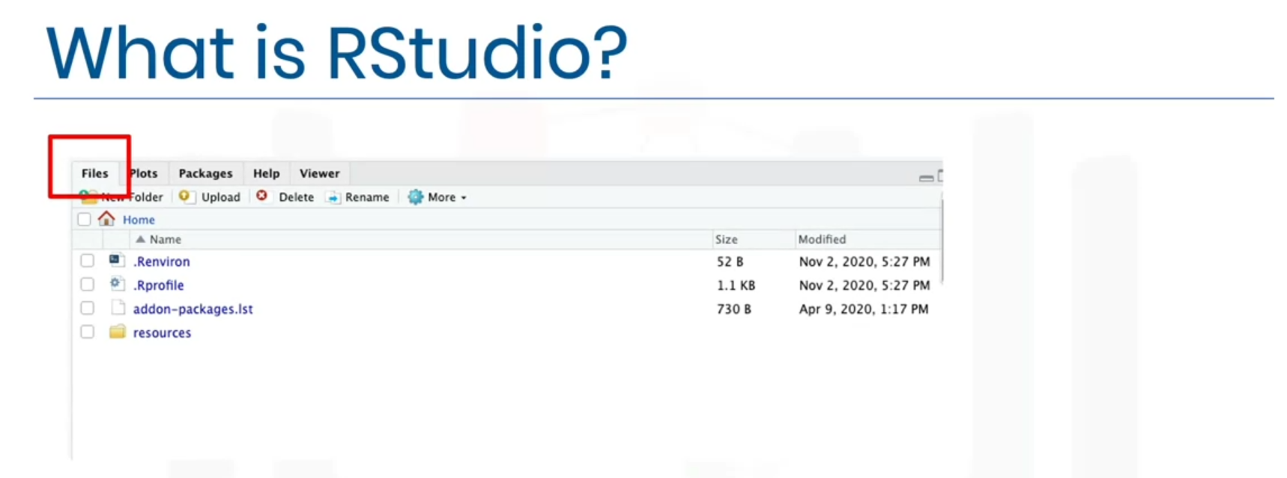

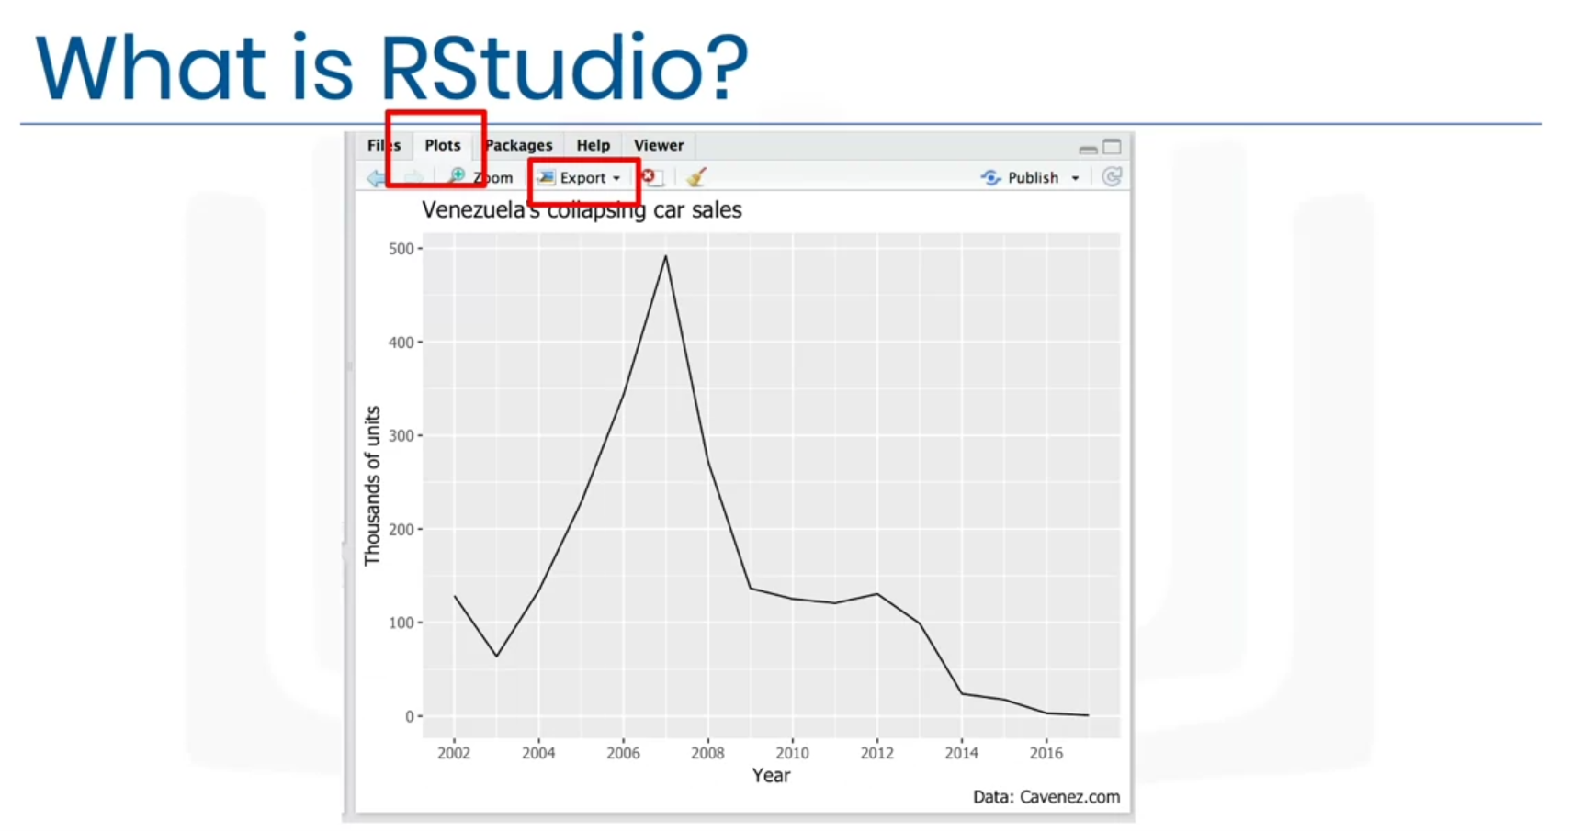

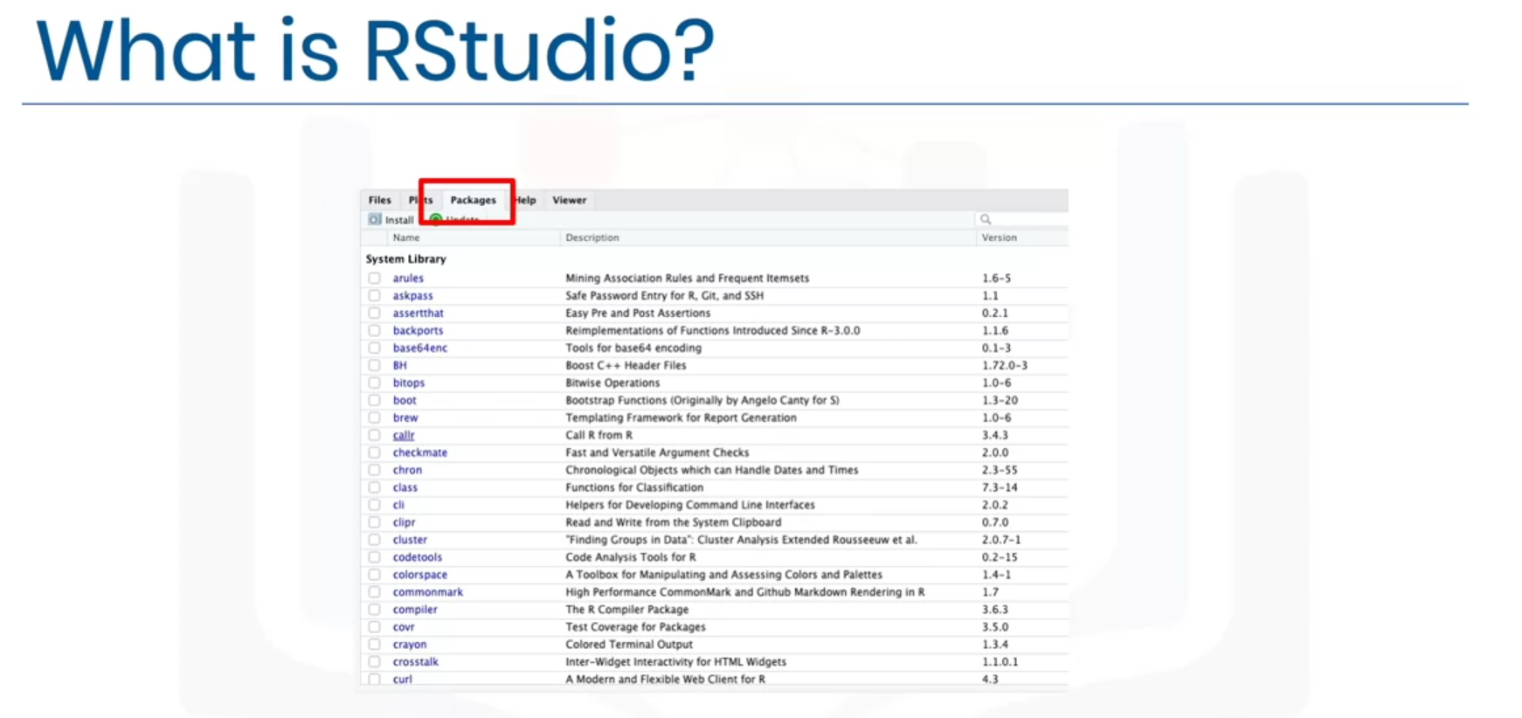

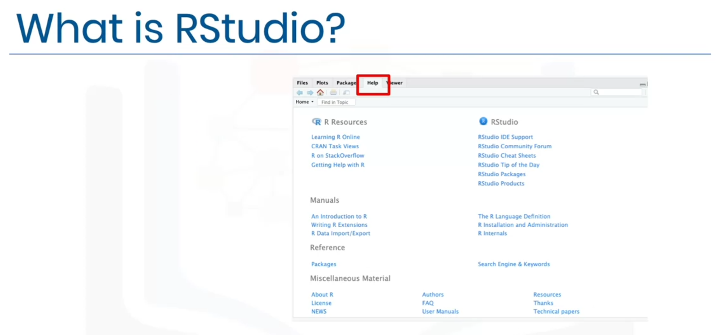

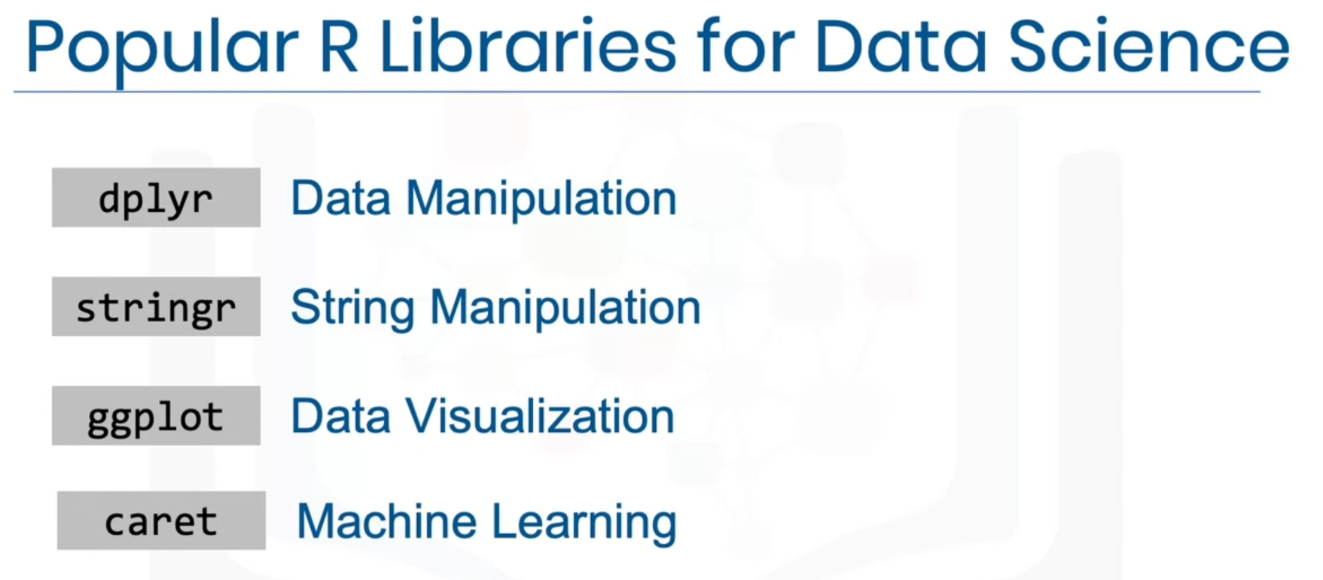

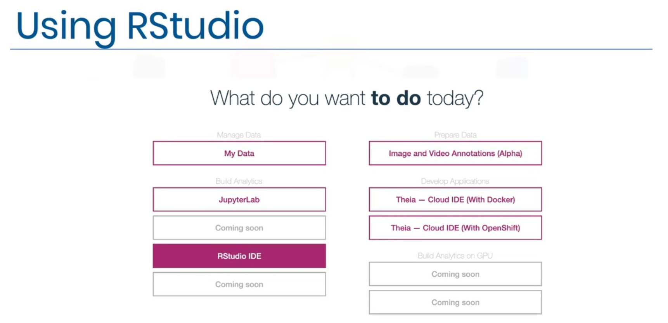

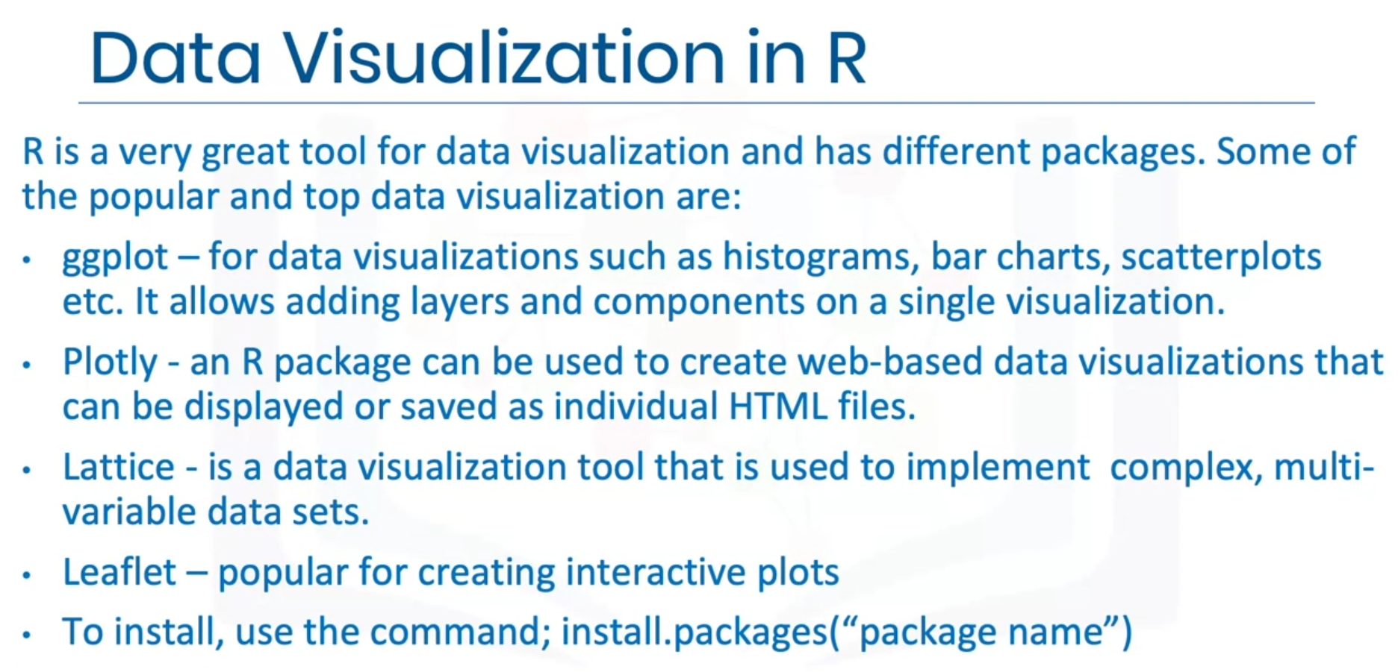

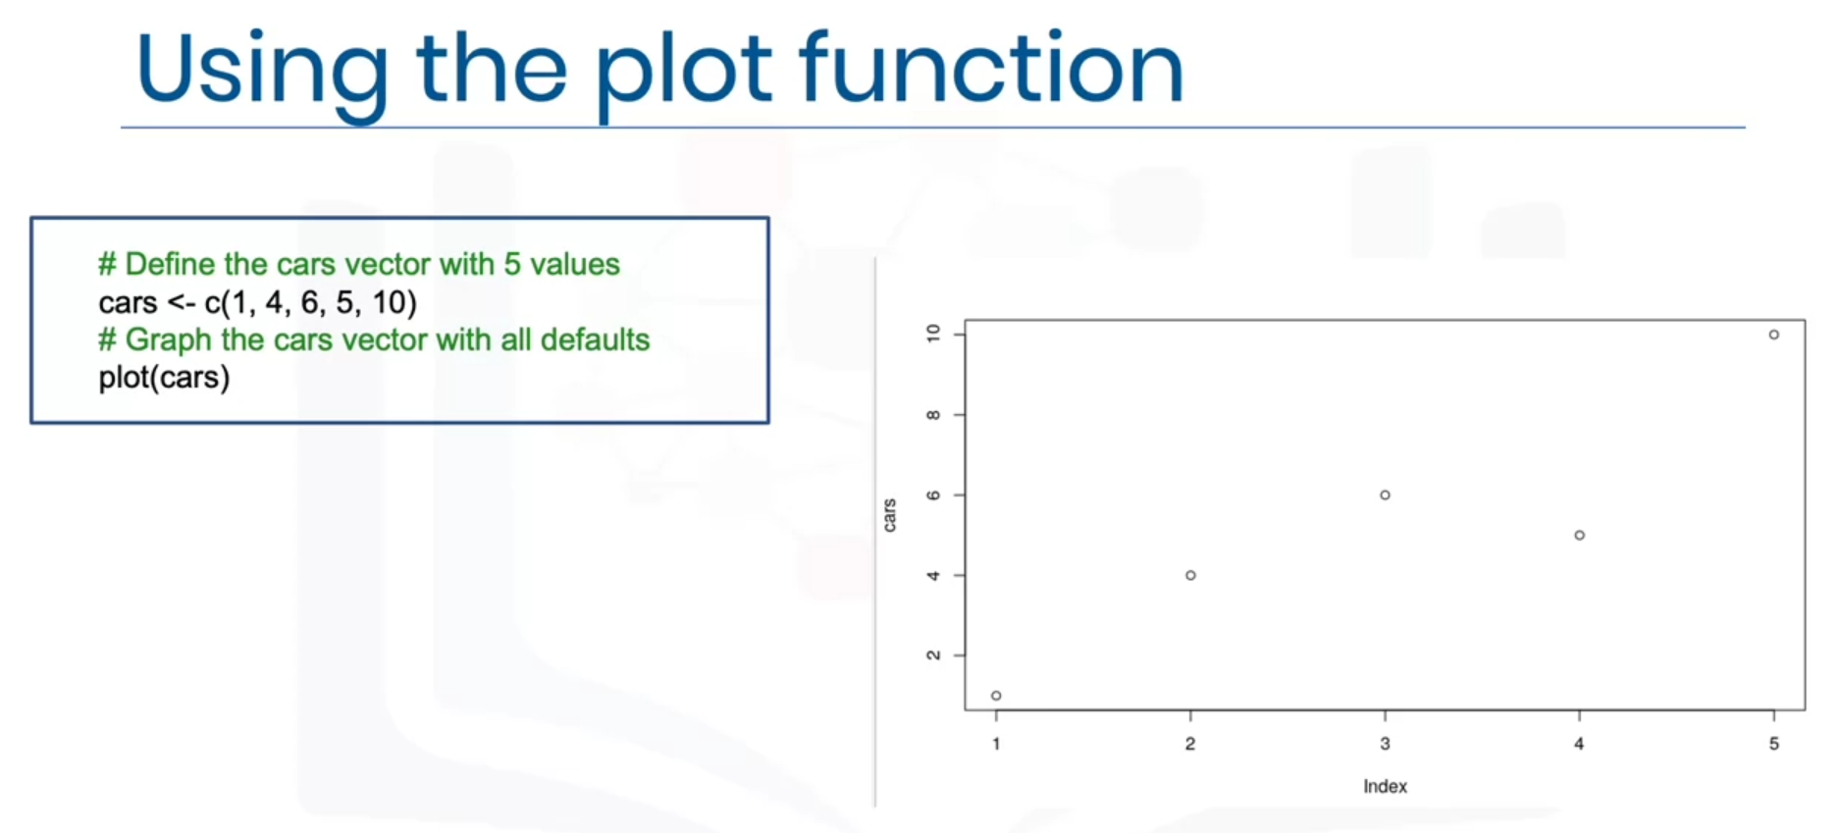

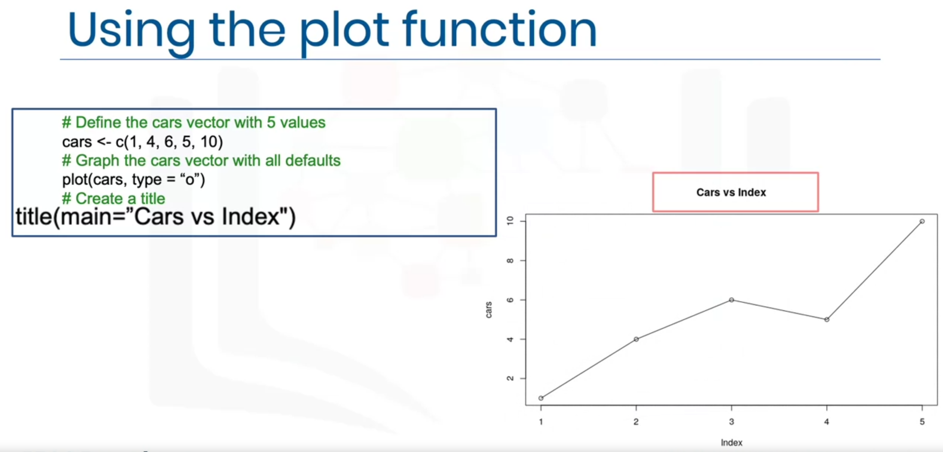

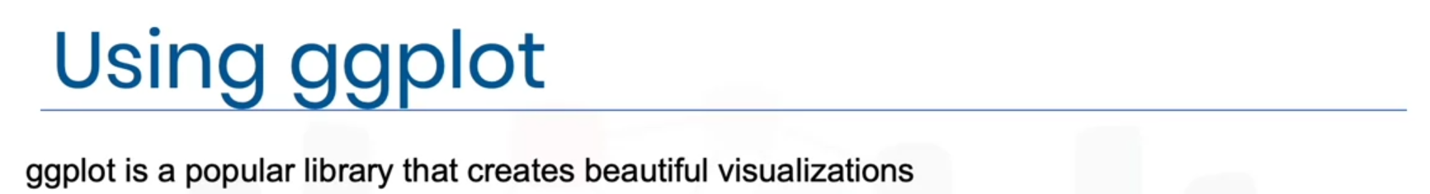

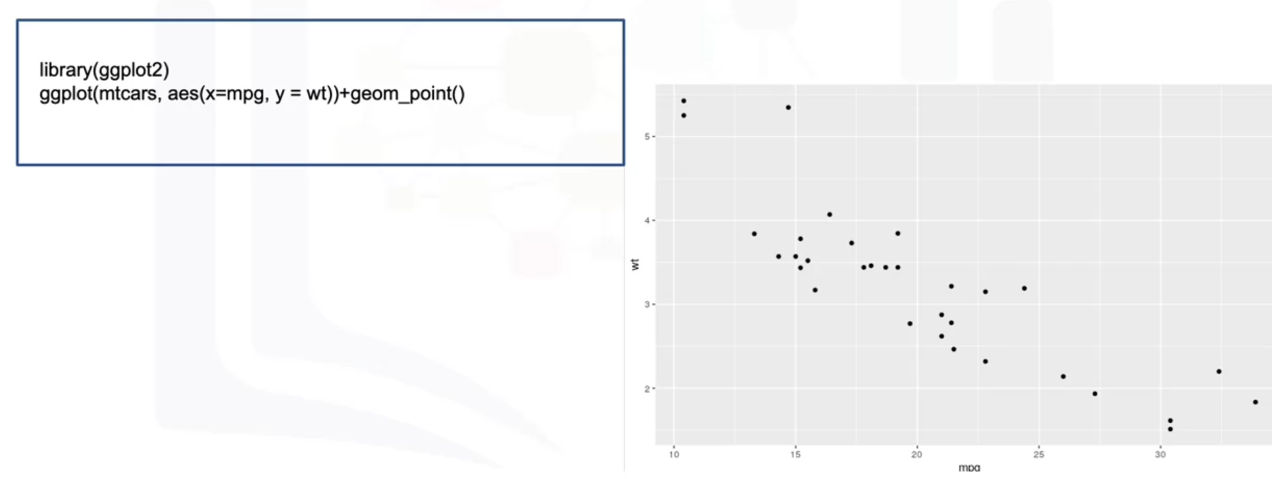

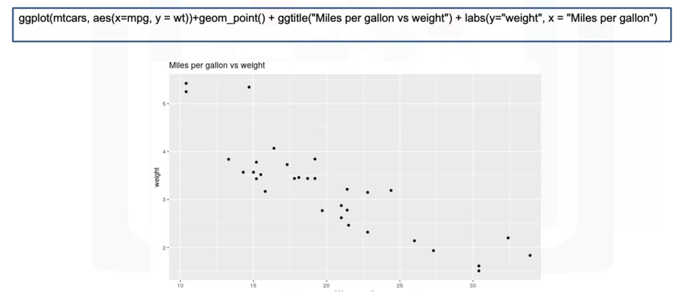

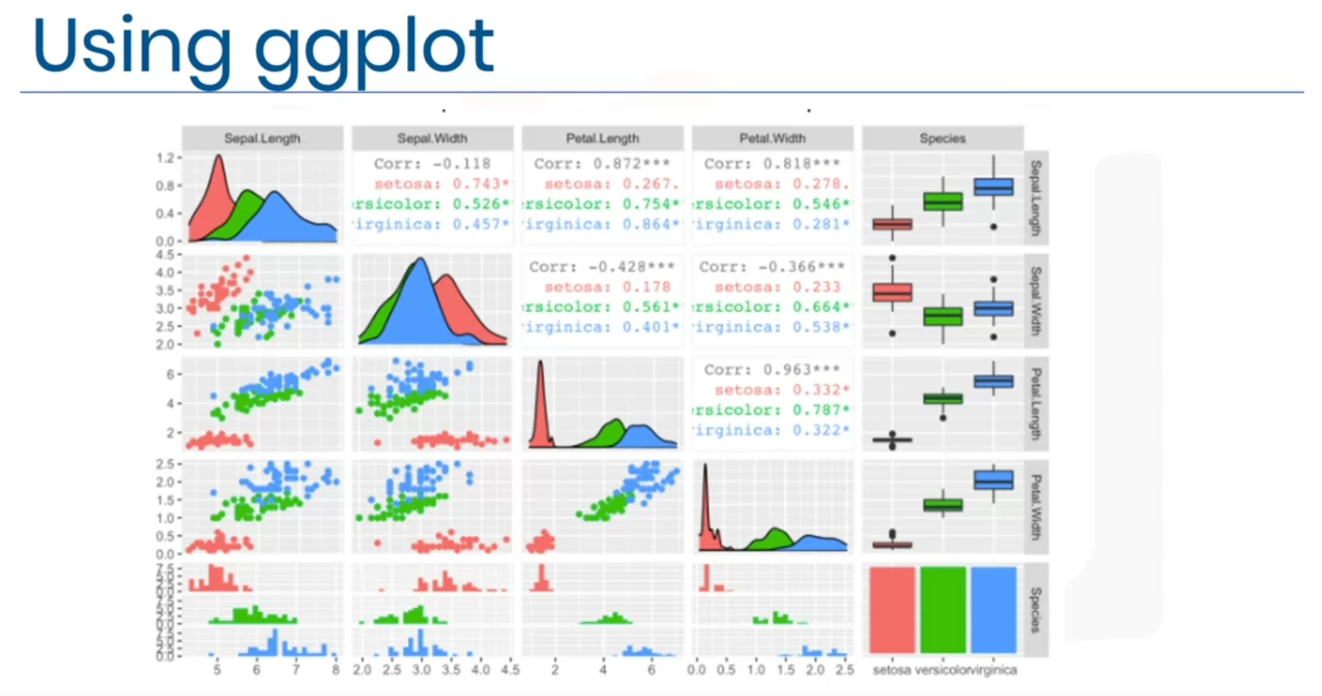

**Getting started with RStudio and Installing packages**

library(datasets)

data(iris)

View(iris)

unique(iris$Species)

Run this command in the console below:

install.packages("GGally", repos = "https://cran.r-project.org", type = "source")

Click Enter to install the package.

**Creating Data Visualizations using ggplot**

library(datasets)

data(mtcars)

head(mtcars, 5)

?mtcars

library(ggplot2)

ggplot(aes(x = disp, y = mpg, ), data = mtcars) + geom_point() + ggtitle("Displacement vs miles per gallon") + labs(x = "Displacement", y = "Miles per gallon")

mtcars$vs <- as.factor(mtcars$vs)

ggplot(aes(x = vs, y = mpg), data = mtcars) + geom_boxplot(alpha = 0.3) + theme(legend.position = "none")

ggplot(aes(x = wt), data = mtcars) + geom_histogram(binwidth = 0.5)

**Plotting within RStudio (Advanced)**

library(datasets)

data(iris)

View(iris)

library(GGally)

ggpairs(iris, mapping = ggplot2::aes(colour = Species))

**GitHub**

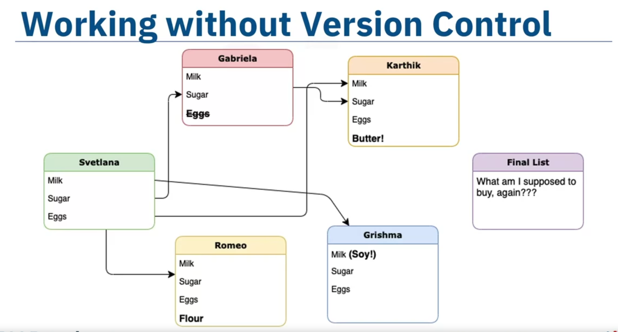 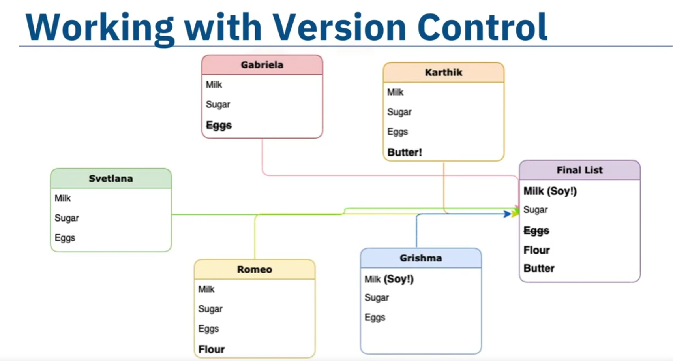

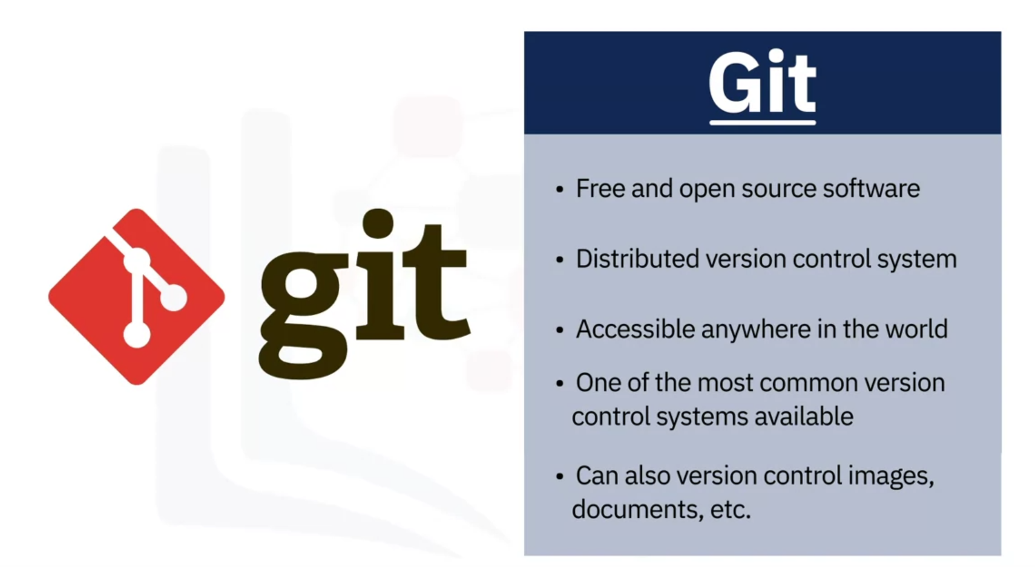

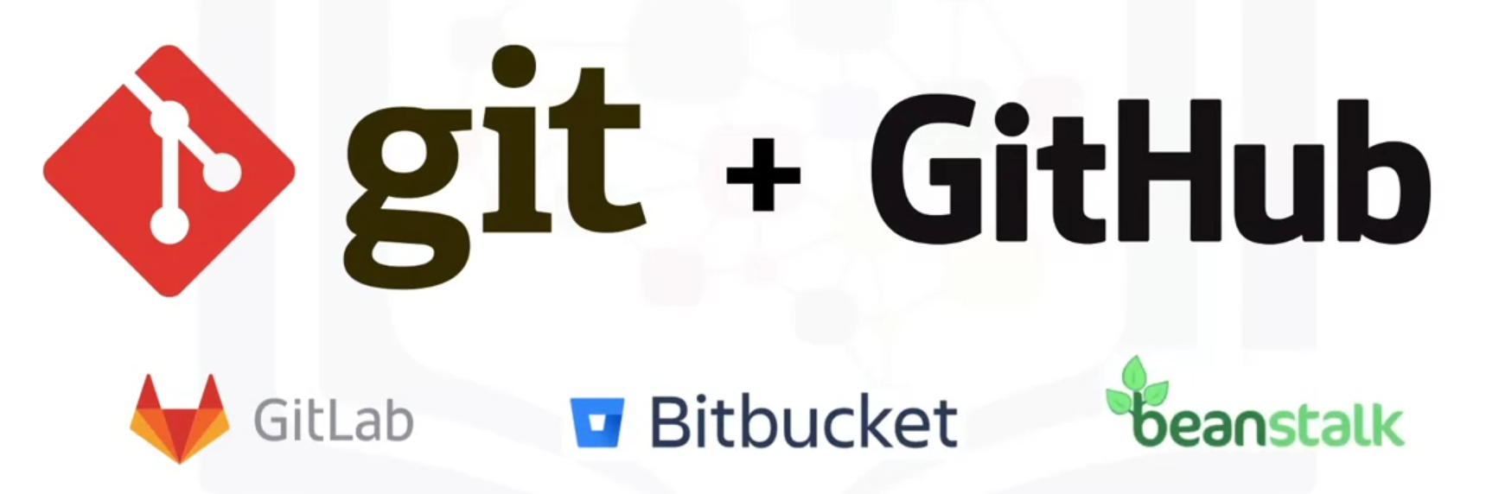

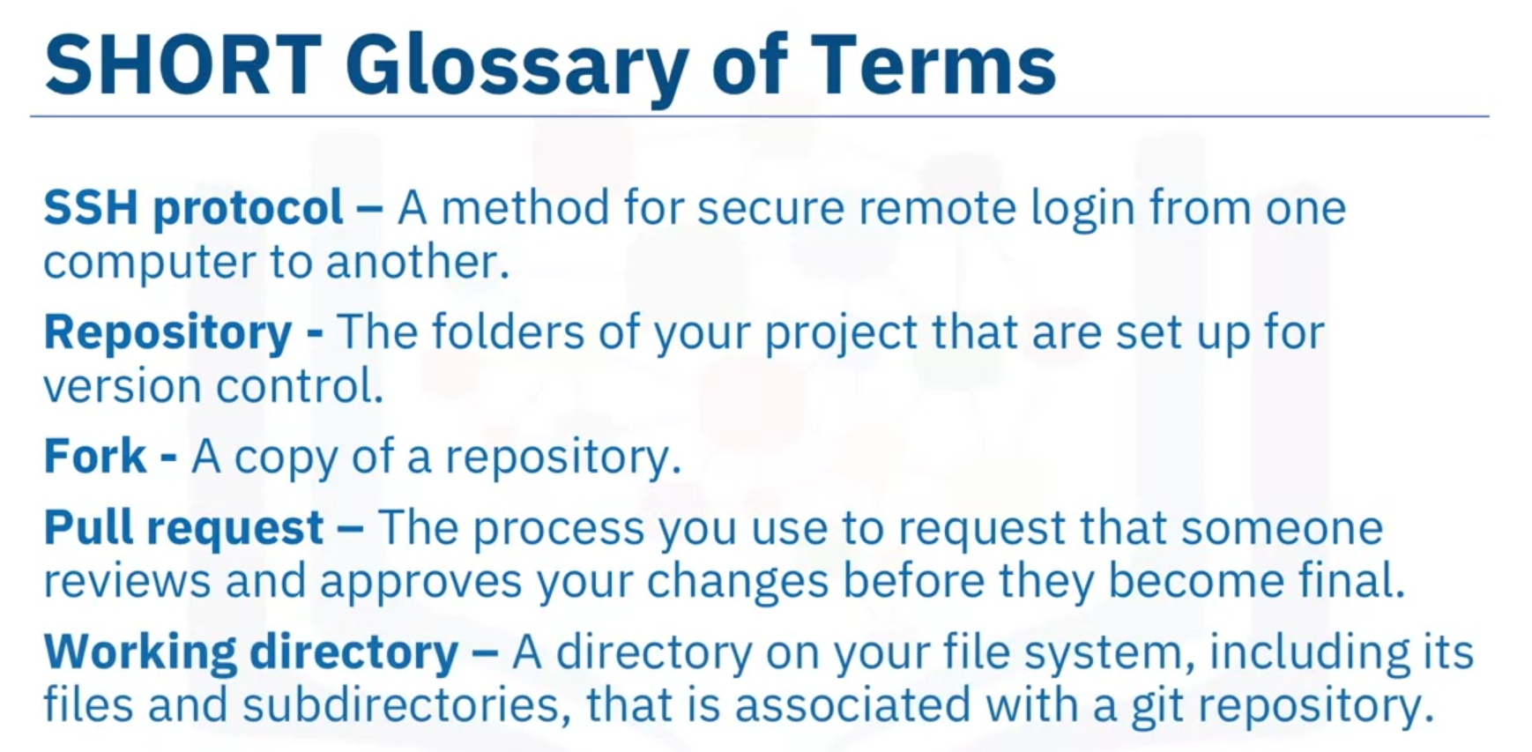

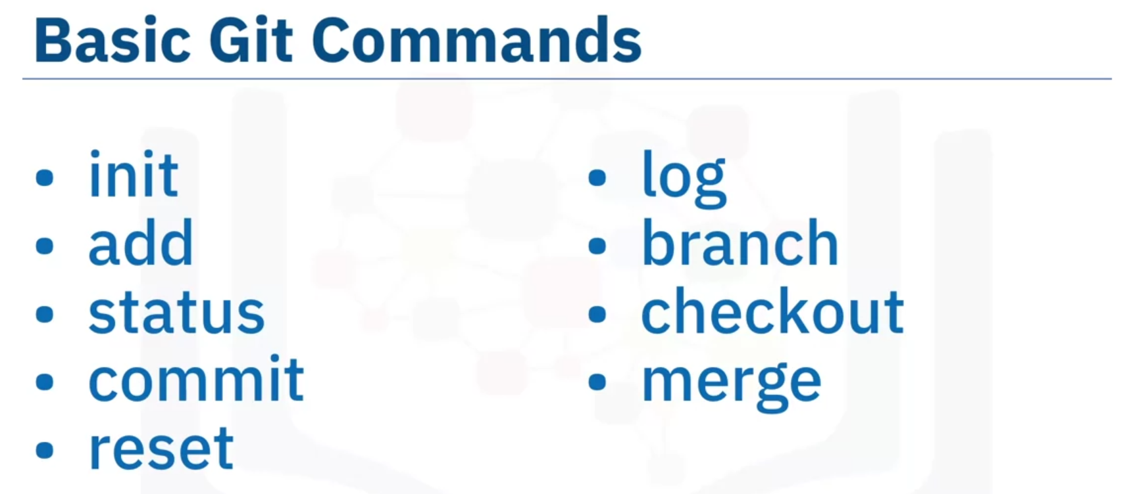

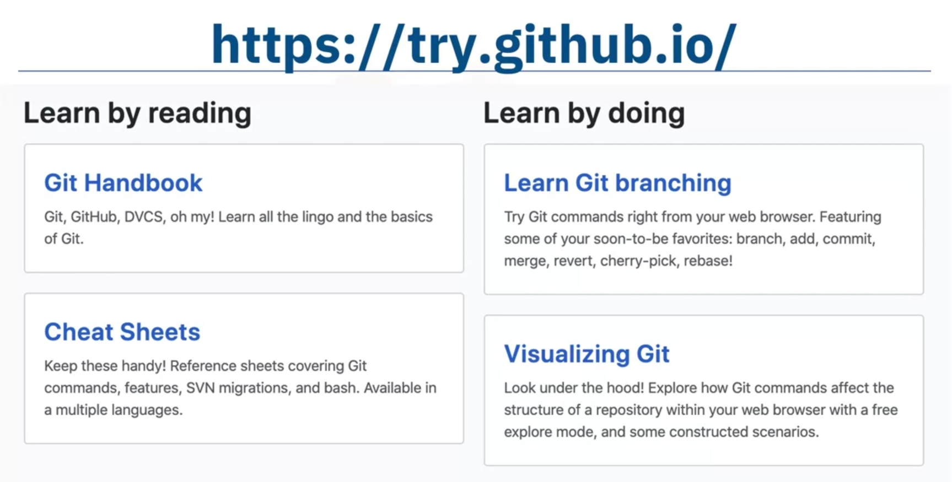

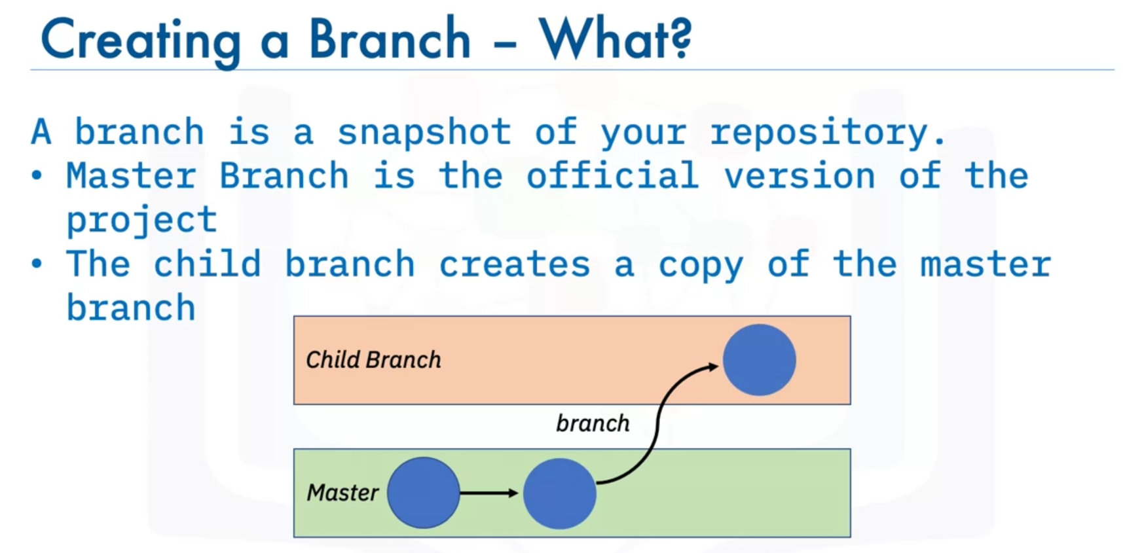

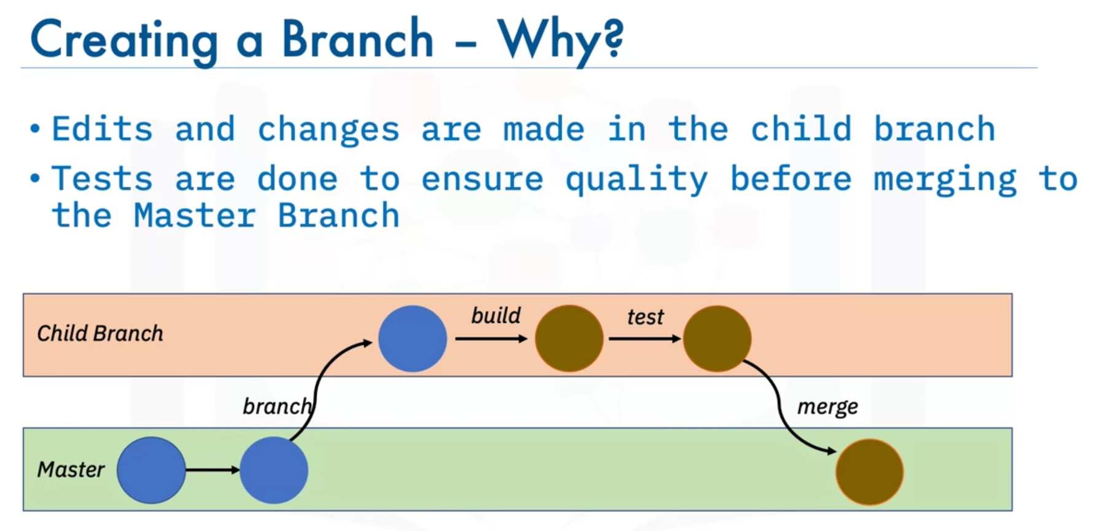

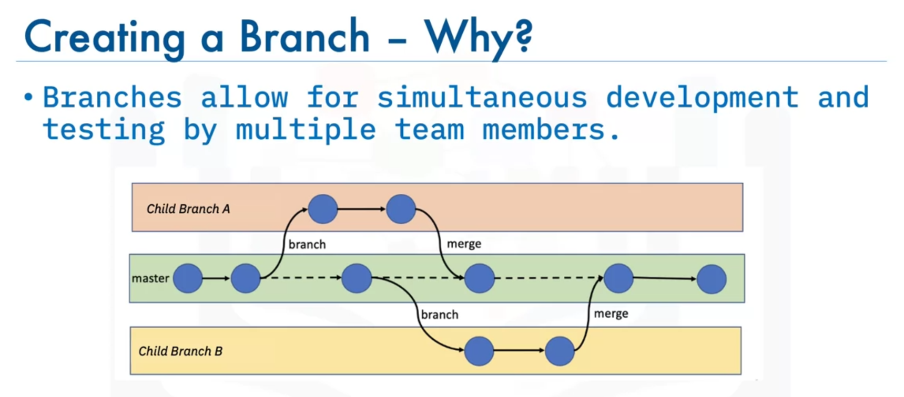

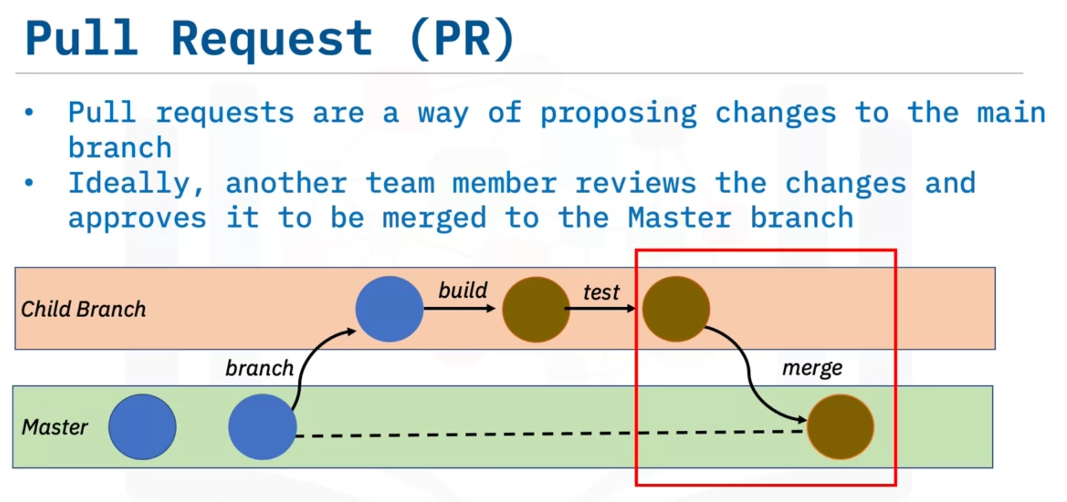

### Pre-requisites for working with GitHub on local machine:

**BASH Installation**

For Windows:

[GitBash Installation](https://cf-courses-data.s3.us.cloud-object-storage.appdomain.cloud/IBMDeveloperSkillsNetwork-DS0105EN-SkillsNetwork/labs/Module2/GitBash_Install.md.html?utm_medium=Exinfluencer&utm_source=Exinfluencer&utm_content=000026UJ&utm_term=10006555&utm_id=NA-SkillsNetwork-wwwcourseraorg-SkillsNetworkCoursesIBMDeveloperSkillsNetworkDS0105ENSkillsNetwork984-2022-01-01)

For Linux/Unix:

For Linux systems installing Git is easy. If you are using a Debian-based distribution like Ubuntu, you can use apt install:

$ sudo apt install git-all

For Fedora, RHEL or CentOS, you can use:

$ sudo dnf install git-all

For Mac:

Open the Terminal

Install homebrew if you don't already have it, then:

$ brew install git

**SSH Key generation**

[Generate SSH Key](https://cf-courses-data.s3.us.cloud-object-storage.appdomain.cloud/IBMDeveloperSkillsNetwork-DS0105EN-SkillsNetwork/labs/Module2/GitHub_SSHKey.md.html?utm_medium=Exinfluencer&utm_source=Exinfluencer&utm_content=000026UJ&utm_term=10006555&utm_id=NA-SkillsNetwork-wwwcourseraorg-SkillsNetworkCoursesIBMDeveloperSkillsNetworkDS0105ENSkillsNetwork984-2022-01-01)

Git is a system for version control of source code. Git is very useful for data science as well, since data science often involves a lot of source code to be written and managed.

The local repository is only accessible by myself. The staging is only accessible by myself. The remote repository is accessible by all contributors.

What is the best process for contributing a bugfix to a foreign repository? Fork the repository, update the fork and create a pull request.

1. Which are the two most used open source tools for data science?

* Notepad
* **RStudio**
* **Jupyter Notebooks / JupyterLab**
* Spyder
* VSCode

2. What tool do most R developers use?

* **RStudio**
* Jupyter Notebooks / JupyterLab

3. What tool do most Python developers use?

* RStudio
* **Jupyter Notebooks / JupyterLab**

4. True or false? Jupyter Notebooks / JupyterLab support development in R.

* **True**
* False

5. Which tool unifies documentation, source code and data visualizations into a single document?

* VSCode
* **Jupyter Notebooks / JupyterLab**
* Notepad

6. Which command is used to install packages in R?

* package(“package name”)
* **install.packages(“package name”)**
* install(“package name”)
* install.package(“package name”)

7. Which of the following functions does RStudio provide?

* Creating relationships between data tables.
* **Editing and execution of R code.**
* Storing data in tables.
* Documenting R code applications.

8. True or False: The Jupyter Notebook kernel must be installed on a local server.

* True
* **False**

9. Which of the following statements about Jupyter Notebook is correct?

* Jupyter Notebook is only available if installed locally on your computer.
* **Jupyter Notebook supports the Visualization of data in charts.**
* Jupyter Notebook provides storage of massive quantities of data in data lakes.
* Jupyter Notebook is a commercial product of IBM.

10. True or false? RStudio supports development in Python.

* **True**
* False